Christian education is important to me because I think that everyone should feel the love that is felt at Immanuel. I especially like the one-on-one help that the teachers give you. I love the family atmosphere that Immanuel has. I have been here since Pre-School. I am very blessed to have a relationship with my Savior, Jesus Christ. I know that I am going to heaven. In Philippians 4:13 it says, “I can do all things through Christ who strengthens me.” I am thankful to have been able to come to such an amazing school. I am proud to be part of God’s amazing family!  (from a recent 8th grade graduate) | YES! I want to Adopt-A-Student!!!  For the 2020 – 2021 school year, I agree to pay $10 a month ($90) toward a students tuition. | Name________________________________________________________  Address______________________________________________________  City_______________________________ State____________ Zip_______  Email____________________________  Make Checks to: Immanuel Lutheran School | Immanuel Lutheran School  Adopt-A-Student  - Our Mission Statement - Share the Gospel so children become disciples of Jesus  - 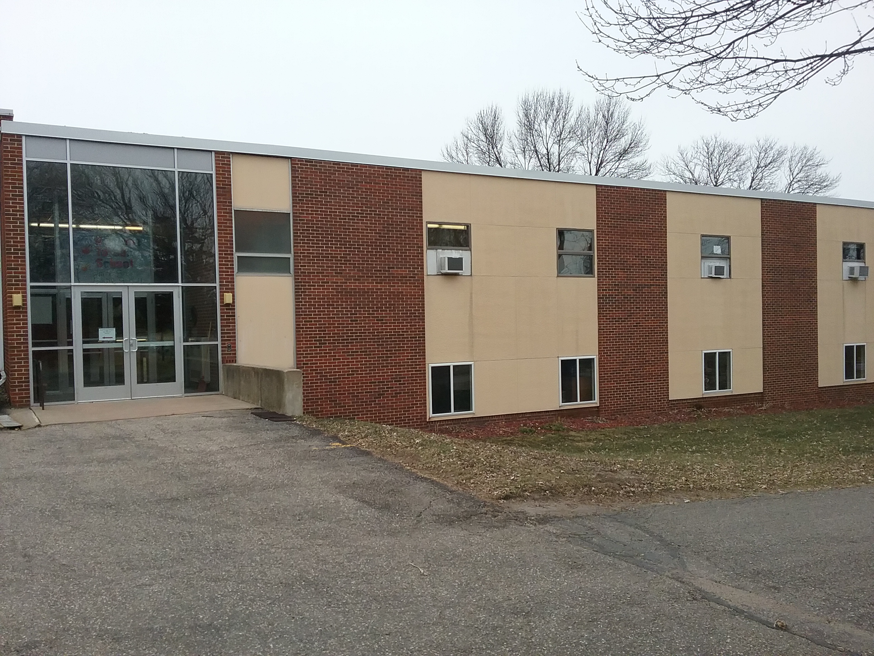  - Giving children the tools to serve

“The essence is family, not just for the kids, but for the families.”  Immanuel Lutheran School provides a Christ-centered education that will develop your child’s God-given talents to God’s glory.  REAL.  PRESENT.  GOD | “Our kids have grown here socially, spiritually, academically – they have done very well. They love to go to school every day!” Kareen –parent of ILS student  Adopt-A-Student fosters the opportunity for caring Christians like you, to help provide a Christian education to children in the Plainview area.  How will this work?  When you agree to Adopt-A-Student, you are agreeing to pay $10 a month ($90 a year) toward a child’s tuition at Immanuel Lutheran School. With hopes of every child being “adopted”, this will help with rising tuition costs for every family. Some students may not be able to continue on at ILS without some help financially. | What Immanuel Lutheran School offers each student –  *A Christ centered education – Jesus in every classroom and every subject  *Pre-K through 8th grade with excellent teachers  *Small class sizes – lower teacher/student ratio  *Sense of Family – everyone knows each other, including all the teachers  *Up to date technology – laptops, tablets, and smart boards  *Leadership/Mentoring skills though Chapel Families  *Extended care – before/after school  *Sports – volleyball, basketball, softball, and soccer  *Choir and hand bell choir  *Band at PEM  Contact Us  Immanuel Lutheran School  30 South Wabasha  Plainview, MN 55964  507-534-2108

